Advanced Driver-Assistance Systems
SW252 - Course Project – Phase 1
Ahmed Wael 202201415

A. Component List
1. Arduino Uno Rev3 with CH340 Uploader
2. Bluetooth Module HC-05 3. L298 Motor Driver Module
4. DC Geared Motor Dual Shaft 3:6VDC 450 rpm with Wheel (D: 65mm X W: 26mm)
5. HC-SR04 Ultrasonic Wave Detector Sensor 3.3V~5V
6. 4 Li-ion Battery 3.7V Rechargeable (Recycled) 18650-1200mAh
7. Photo-resistor LDR Light Sensor Module
8. Character LCD 2x16 Blue with Soldering Serial interface IIC/I2C Module
9. Red LED 5mm
10. Green LED 5mm

B. System architecture schematic
Connections Overview
1. Bluetooth Communication
- HC-05 TX → Arduino Pin 10
- HC-05 RX → Arduino Pin 11
- Used to receive:
  - Movement commands (F, B, L, R, S)
  - Speed levels (0–9, q)
2. Motor Control (L298 Module)
- ENA (PWM speed control) → Arduino Pin 3
- ENB (PWM speed control) → Arduino Pin 9
- IN1 → Arduino Pin 5
- IN2 → Arduino Pin 4
- IN3 → Arduino Pin 7
- IN4 → Arduino Pin 6
These pins control:
- Forward / backward movement
- Left / right turning
- Smooth acceleration and deceleration using PWM
3. Ultrasonic Sensor (HC-SR04)
- Trig → Arduino Pin 12
- Echo → Arduino Pin 8
Used to:
- Measure distance to obstacles
- Calculate Time-To-Collision (TTC)
- Reduce speed automatically when unsafe
4. Light Detection System
- LDR Output → Arduino A0
- Headlight LED → Arduino Pin 2
If ambient light is low, headlights turn ON automatically.
5. LCD Display (I2C)
- SDA → Arduino A4
- SCL → Arduino A5
Displays:
- Speed value
- Light status
- Obstacle safety state
6. Power Supply
- 4× Li-ion batteries
- Motor driver powered directly
- Arduino powered through regulated input

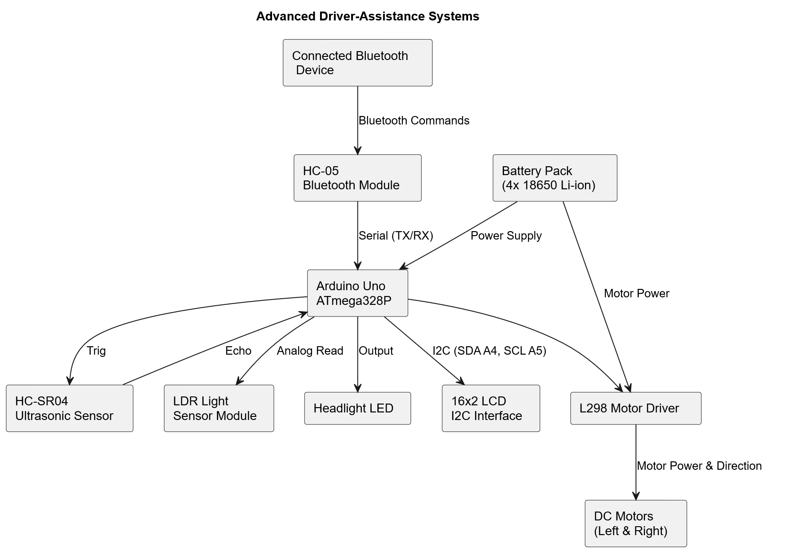

C. Program Modules with Comments
1. Initialization Module (setup())
- Initialize serial communication
- Initialize Bluetooth
- Initialize LCD
- Configure all I/O pins
- Display startup message

2. Main Control Loop (loop())
- Continuously read inputs
- Apply safety logic
- Control motors
- Update display

3. Bluetooth Command Processing
- Maps Bluetooth characters (0–9, q) to PWM speed values
- Updates target motor speed

4. Ultrasonic Distance & Safety Module
- Measure obstacle distance
- Calculate Time To Collision (TTC)
- Reduce speed automatically when TTC is unsafe
5. Speed Control Module (Smooth Acceleration)
- Gradually adjust motor speed
- Prevent sudden acceleration or braking
- Uses PWM on ENA and ENB pins

6. Movement Control Module
Command | Action
F | Move forward
B | Move backward
L | Turn left
R | Turn right
S / default | Stop

Motor Direction Logic:
Implemented using IN1–IN4 pin combinations.

7. LDR
- Detect surrounding light
- Turn headlights ON/OFF automatically

8. LCD Display Module
Displays:
- Speed
- Light status (ON/OFF)
- Safety state (SAFE / OBSTACLE)

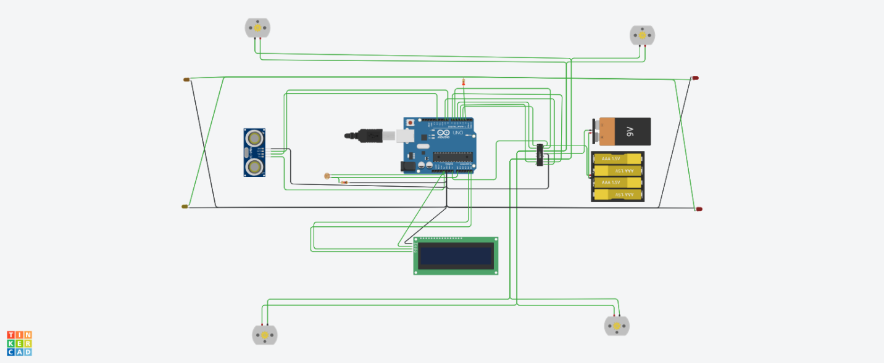

https://www.tinkercad.com/things/biWAMIYXoqj-phase-1-project?sharecode=WANjqpi-d3QQBnAoKnWevCtdt4a--Y42-4BOKmglXJU&authuser=0

